Advocacy
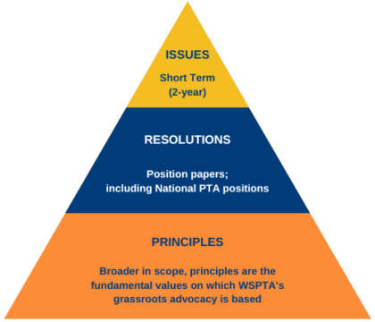
Our PTSA advocacy work is directed by our member approved resolutions, principles, and legislative platform. In 2021 we introduced our Focus on Advocacy program.

As the largest child advocacy organization in the state, Washington State PTA’s (WSPTA’s) power is in the grassroots efforts of our members. WSPTA’s foundation is our membership. Without our members, we would not have the thousands of voices to advocate for all children and families, which is the focus of our mission.
WSPTA members work from a comprehensive legislative platform to address issues affecting the whole child. Our comprehensive advocacy efforts include education, family engagement, health & well-being, and safety. Each of these areas impact the current and future success of Washington children — and our state as a whole.

Legislative Platform
The Washington State PTA legislative platform is a two-year platform to mirror the Washington state legislative cycle. In the even-numbered years, the new platform is voted on by members at the legislative assembly in the fall. The top five issues become our short-term platform and consist of our priority issues when advocating throughout the year.

During the Washington state legislative session, WSPTA will send action alerts and informational broadcasts to WSPTA members who have subscribed to WSPTA’s Action Network Group. These action alerts are quick, easy ways to communicate with your legislators on topics they are actively working on.

Your voice matters!
We need your stories, we need your voice, and we need you! PTA’s legacy is strong because of passionate advocates just like you who build our legislative platform, one resolution at a time.
Focus on Advocacy Week is scheduled for February 20-24, 2023. During this week many advocates will meet with their legislators and participate in the daily call to actions. However, we know that advocacy is not a one-day event; it is an everyday action. And so, we encourage members to continue to stay informed and engaged throughout the year, keeping our efforts focused on the mission. #WSPTAOneVoice

